# [***81 FR 60257***](https://advance.lexis.com/api/document?collection=administrative-codes&id=urn:contentItem:5KKS-JF50-006W-83M3-00000-00&context=)

Vol. 81, No. 170, Thursday, September 1, 2016

Rules and Regulations

**Reporter**

81 FR 60257 *

***Federal Register* > *2016* > *September* > *Thursday, September 1, 2016* > *Rules and Regulations* > *FEDERAL TRADE COMMISSION (FTC)***

**Title:** **Premerger Notification; Reporting and Waiting Period Requirements**

**Action:**  Final rule.

**Agency**

FEDERAL TRADE COMMISSION (FTC)

**Administrative Code Citation**

**16 CFR Part 803**

**Synopsis**

**SUMMARY:** The Commission is amending the Hart-Scott-Rodino ("HSR") Premerger Notification Rules (the "Rules") that require the parties to certain mergers and acquisitions to file reports with the Federal Trade Commission ("the Commission" or "FTC") and the Assistant Attorney General in charge of the ***Antitrust*** Division of the Department of Justice ("the Assistant Attorney General" or "DOJ") (together the "***Antitrust*** Agencies" or "Agencies") and to wait a specified period of time before consummating such transactions. These amendments update the Rules to allow for submission of the Premerger Notification and Report Form ("Form") and accompanying documents (together the "HSR Filing") on digital video/versatile disc ("DVD"), and clarify the Instructions to the Form.

**Text**

**SUPPLEMENTARY INFORMATION:**

**Introduction**

Section 7A of the Clayton Act (the "Act") requires the parties to certain mergers or acquisitions to file with the Commission and DOJ to allow the Agencies to conduct their initial review of a proposed transaction's ***competitive*** impact and requires the parties to wait a specified period of time before consummating such transactions. The reporting requirement and the waiting period that it triggers are intended to enable the ***Antitrust*** Agencies to determine whether a proposed merger or acquisition may violate the ***antitrust*** laws if consummated and, when appropriate, to seek a preliminary injunction in federal court to prevent consummation, pursuant to Section 7 of the Act.

Section 7A(d)(1) of the Act, [*15 U.S.C. 18a(d)(1)*](https://advance.lexis.com/api/document?collection=statutes-legislation&id=urn:contentItem:4YF7-GNJ1-NRF4-451X-00000-00&context=), directs the Commission, with the concurrence of the Assistant Attorney General, in accordance with the Administrative Procedure Act, *5 U.S.C. 553*, to require that premerger notification be in such form and contain such information and documentary material as may be necessary and appropriate to determine whether the proposed transaction may, if consummated, violate the ***antitrust*** laws. Section 7A(d)(2) of the Act, [*15 U.S.C. 18a(d)(2)*](https://advance.lexis.com/api/document?collection=statutes-legislation&id=urn:contentItem:4YF7-GNJ1-NRF4-451X-00000-00&context=), grants the Commission, with the concurrence of the Assistant Attorney General, in accordance with *5 U.S.C. 553*, the authority to define the terms used in the Act and prescribe such other rules as may be necessary and appropriate to carry out the purposes of Section 7A.

Pursuant to that authority, the Commission, with the concurrence of the Assistant Attorney General, developed the Rules, codified in 16 CFR parts 801, 802 and 803, and the Form and its associated Instructions, codified at part 803--appendix, to govern the form of premerger notifications to be provided by merging parties.

HSR Filings provide the Agencies with the information and documentary material necessary for an initial evaluation of the potential anticompetitive impact of significant mergers, acquisitions and certain similar transactions. Currently, all HSR Filings are submitted in paper. Through these amendments to the Rules, the Agencies will allow the submission of HSR Filings digitally on DVD ("DVD filings"). The acceptance of DVD filings requires certain conforming changes to the Instructions to the Form, so the Commission is also taking this opportunity to clarify the Instructions and make them easier to use.

**Statement of Basis and Purpose for the Commission's Revision of Its Premerger Notification Form, Instructions and Rules**

Since the inception of the HSR program, the HSR Form and its attachments have been submitted in paper. In 2006, an electronic filing option was introduced that would allow filers to upload HSR Filings directly to the Agencies but that option failed to gain traction due to the limitations of the underlying technology, and it was soon discontinued. While the Agencies continue to explore an electronic filing option, they have decided to accept the submission of HSR Filings digitally on DVD. Accordingly, the Commission amends part 803 to delete references to the discontinued electronic filing option and revises these sections and the Instructions to the Form found in the appendix to part 803 to allow for DVD filings. Documents submitted by the parties with the filing are typically created and stored in digital format. Allowing parties to submit these digital files on electronic media will be more efficient and cost-effective, providing benefits to filing parties as well as the Agencies:

--Currently, those submitting HSR Filings must provide five paper copies of their Form, consisting of one original and one copy to the FTC, and three copies to DOJ, as well as one set of Documentary Attachments to each Agency. DVD filing will eliminate the expensive and time-consuming printing and duplication of documents, and allow for a more efficient filing process for filing parties.

--DVD filing will ease the physical delivery of voluminous HSR Filings to the Agencies, and facilitate the processing and review of filings within each Agency.

--DVD filing will allow for more efficient and less costly storage options for the Agencies

To provide maximum flexibility, filing parties will still have the traditional option of submitting HSR Filings in paper. Submitting an HSR Filing partially on DVD and partially in paper will not be permitted, however. Additionally, DVD submissions must be accompanied by original hard copies of the cover letter, certification and affidavit. The individual rule amendments associated with DVD filing are described more fully below.

Additionally, this rulemaking makes minor changes to the Form Instructions, **[*60258]** many of which are unrelated to DVD filing, to reduce the burden on filing parties by making it easier to prepare the Form and comply with the HSR Filing requirements. These changes are not substantive in nature, and involve formatting, clarification, and simplification, as well as the deletion of immaterial language, with the goal of eliminating confusion for filing parties, as noted below.

**Section 803.1 Notification and Report Form**

The internet portal established in 2006, [*www.hsr.gov*](http://www.hsr.gov)*,* to allow the electronic filing of HSR Filings is no longer technologically viable, and references to HSR.gov are removed from all Rules in which they appear and the Instructions.

**Section 803.2 Instructions Applicable to Notification and Report Form**

Section 803.2(e)(1) currently allows filers to forego the physical production of documents responsive to Item 4(b) by incorporating by reference documents previously filed with the Agencies in other transactions. The purpose of the rule was to avoid the costly duplication of responsive documents that were already in the possession of the Agencies. However, given § 803.2(e)(2), which allows parties to cite to an Internet address rather than provide hard copies of responsive documents, and the ease of copying documents onto a DVD without any expensive hard copy duplication, § 803.2 is being amended to delete § 803.2(e)(1). The existing, current, § 803.2(e)(2) will be renumbered to § 803.2(e), and the new § 803.2(e) has been amended for clarity.

To ensure the submission of compatible and readable electronic files, and to avoid problems and delays in processing HSR Filings, paragraph (f) of § 803.2 has been amended to require the use of specific formatting when submitting an HSR Filing on DVD, and to remove the reference to [*www.hsr.gov*](http://www.hsr.gov)*.* The filing person is responsible for ensuring that the formatting requirements are observed and is subject to a notice of deficient filing if an unacceptable format is submitted. *See* [*http://www.ftc.gov/enforcement/premerger-notification-program*](http://www.ftc.gov/enforcement/premerger-notification-program) for all current DVD Filing format requirements.

**Section 803.3 Statement of Reasons for Noncompliance**

Section 803.3 identifies the specific information that a filing person must provide when not responding to an Item on the Form. Paragraph (d) identifies the specifics of making a claim of privilege. Paragraph (d) is amended to require the titles and/or positions of the author of a document, the addressee, and all recipients of the document being withheld or redacted under a claim of privilege to enable the Agencies to better assess if the privilege applies.

**Section 803.5 Affidavits Required**

Section 803.5 requires an affidavit from the filing person attesting to the good faith intention of the person filing to proceed with the transaction. The affidavit must be attached to the Form at the time of filing. Paragraphs (a)(1), (a)(3), and (b) are amended to address inclusion of the affidavit when using the DVD filing option. If only a scanned version of the signed affidavit is available at the time of filing, it must be submitted on the DVD, and the original signed hard copy should be provided to the FTC as soon as possible.

**Section 803.10 Running of Time**

Persons required by the Act to submit HSR Filings must comply with specified statutory waiting periods before consummating the transaction. Section 803.10(c)(1)(i) is amended to define the "date of receipt and means of delivery" for purposes of determining when the waiting period begins for filings submitted on DVD. Delivery is to be effected by providing a DVD filing directly to the designated agency offices, by either hand or certified or registered mail, FedEx or UPS, during normal business hours.

References and paragraphs relating exclusively to "electronic" filing, as well as references to [*www.hsr.gov*](http://www.hsr.gov)*,* have been deleted to avoid confusion, as the submission of filings electronically is not currently available.

**Appendix to Part 803--Notification and Report Form and Instructions**

A number of changes have been made to the Form Instructions, including changes unrelated to DVD filing, that are intended to clarify the Instructions and simplify the process of completing an HSR Form. Many of these changes involve new formatting or the substitution or deletion of a word, sentence or paragraph. The more significant changes entail the following amendments:

"Filing"

Accounts for the option of filing using a DVD, including specific formatting and submission requirements.

"Responses"

Clarifies that estimated financial information provided in the Form should include an "est." notation. Also specifies that additional pages should be included within the Form, not with the Documentary Attachments.

"Amount Paid"

Eliminates the requirement for an explanatory attachment regarding valuation.

"Payer Identification" and "Method of Payment"

Clarifies the process and requirements for submitting HSR filing fees.

"Item 1(g)"

Specifies that identification of a second contact person is required.

"Item 2(d)"

Clarifies how to respond where a transaction involves a mixed deal including voting securities, and/or non-corporate interests, and/or assets.

"Item 3(a)"

Reorganized and reworded for clarity. Clarifies that the description of the transaction should include a brief and simple description of the relevant assets or business operation(s) to be acquired. Deletes requirement for identification of expected dates of major events and deletes paragraph discussing acquisitions "from a holder other than the issuer or unincorporated entity" to reduce confusion.

"Item 3(b)"

Clarifies that agreement schedules are not required unless they represent some agreement between the parties (*e.g.,* a non-***compete***). Specifies that parties filing on a letter of intent may also submit a draft of the definitive agreement, if one exists.

"Item 4(b)"

Reorganized and amended to clarify the types of reports that are acceptable (*e.g.,* unaudited reports that are relied upon by the board are permitted), and from which entities reports are required.

"Items 4(c) and 4(d)"

Clarifies that document title, date, and author information is required for both 4(c) and 4(d) documents. Additionally amended to clarify the proper labeling convention for these documents, as well as the privilege log requirements outlined in § 803.3(d).

"Item 5(a)"

Simplifies the instructions.

"Item 6(b)"

Amended to clarify that only shareholders with 5% or more, but less than 50% must be identified.

"Item 6(c)"

Clarifies the instructions.

"Item 7"

Amended to clarify that all six-digit NAICS industry code overlaps must be reported, regardless of whether there is a ten-digit NAICS overlap.

"Item 7(b)"

Amended to clarify which entities should be listed. **[*60259]**

"Item 7(c)"

Amended to change the order and organization of the NAICS codes for clarity, and renumbered the sub-sections. Amended to clarify that geographic information should be provided by state postal code abbreviations, including identifying the number of states reported, and that a response of "national" is acceptable in certain cases in lieu of listing every state.

"Item 7(c)(iv)"

Amended to more clearly state that county and city/town information is required for the specific NAICS codes outlined in this section. Reformatted for readability.

"Item 8"

Amended to clarify that Item 8 is related to codes reported in Item 5.

**Administrative Procedure Act**

The Commission finds good cause to adopt these changes without prior public comment. Under the Administrative Procedure Act ("APA"), notice and comment are not required "when the agency for good cause finds (and incorporates the finding and a brief statement of reasons therefore in the rules issued) that notice and public procedure thereon are impracticable, unnecessary, or contrary to the public interest." *5 U.S.C. 553(b)(3)(B)*.

The Commission is updating the Rules, Form and Instructions to provide the option of submitting HSR Filings on DVD, and to clarify the Form Instructions. Paper copy submission will remain available. These amendments to the HSR Rules and Form fall within the category of rules covering agency procedure and practice that are exempt from the notice-and-comment requirements of the APA. *See* *5 U.S.C. 553(b)(A)*. Because the amendments are not substantive in nature, they are also not subject to the delayed effective date provisions of the APA. *See* *5 U.S.C. 553(d)* (substantive rules may take effect no sooner than 30 days after publication).

For these reasons, the Commission finds that there is good cause for adopting this final rule as effective on September 1, 2016 without prior public comment.

**Regulatory Flexibility Act**

The Regulatory Flexibility Act, *5 U.S.C. 601*-612, requires that the agency conduct an initial and final regulatory analysis of the anticipated economic impact of the proposed amendments on small businesses, except where the agency head certifies that the regulatory action will not have a significant economic impact on a substantial number of small entities. *5 U.S.C. 605*. The Regulatory Flexibility Act requirements apply, however, only to rules or amendments that are subject to the notice-and-comment requirements of the APA. *See* *5 U.S.C. 603*, *604*. Because these amendments are exempt from those APA requirements, as noted earlier, they are also exempt from the Regulatory Flexibility Act requirements. In any event, because of the size of the transactions necessary to invoke an HSR Filing, the premerger notification rules rarely, if ever, affect small businesses. Indeed, amendments to the Act in 2001 were intended to reduce the burden of the premerger notification program by exempting all transactions valued at less than $ 50 million (as adjusted annually). Further, none of the proposed rule amendments expands the coverage of the premerger notification rules in a way that would affect small business. Accordingly, to the extent, if any, that the Regulatory Flexibility Act applies, the Commission certifies that these proposed rules will not have a significant economic impact on a substantial number of small entities. This document serves as notice of this certification to the Small Business Administration.

**Paperwork Reduction Act**

These changes do not contain any record maintenance, reporting or disclosure requirements that would constitute agency "collections of information" that would have to be submitted for clearance and approval by the Office of Management and Budget under the Paperwork Reduction Act of 1995, [*44 U.S.C. 3501*](https://advance.lexis.com/api/document?collection=statutes-legislation&id=urn:contentItem:4YF7-GNM1-NRF4-408K-00000-00&context=)-[*3521*](https://advance.lexis.com/api/document?collection=statutes-legislation&id=urn:contentItem:4YF7-GWR1-NRF4-43SN-00000-00&context=).

***Regulations***

**List of Subjects in 16 CFR Part 803**

***Antitrust***.

For the reasons stated in the preamble, the Federal Trade Commission amends 16 CFR part 803 as set forth below:

1. The authority citation for part 803 continues to read as follows:

**Authority:** [*15 U.S.C. 18a(d)*](https://advance.lexis.com/api/document?collection=statutes-legislation&id=urn:contentItem:4YF7-GNJ1-NRF4-451X-00000-00&context=).

1. Amend § 803.1 by revising paragraph (a) to read as follows:
2. **t Form.**
3. The notification required by the act shall be the Notification and Report Form set forth in the appendix to this part, as amended from time to time. All acquiring and acquired persons required to file notification by the act and these rules shall do so by completing and filing the Notification and Report Form, in accordance with the instructions thereon and these rules. The current version of the Form can be obtained at [*http://www.ftc.gov*](http://www.ftc.gov)*.*

   *    *    *    *    *

1. Amend § 803.2 by revising paragraphs (e) and (f) to read as follows:
2. **e to Notification and Report Form.**

*    *    *    *    *

1. For documents required by item 4(b) of the Notification and Report Form, a person filing the notification may, instead of submitting a document, provide a cite to an operative Internet address directly linking to the document, if the linked document is complete and payment is not required to access the document. If an Internet address becomes inoperative during the waiting period, or the document is otherwise rendered inaccessible or incomplete, upon notification by the Commission or Assistant Attorney General, the parties must make the document available to the agencies by either referencing an operative Internet address where the complete document may be accessed or by providing paper copies to the agencies as provided in § 803.10(c)(1) by 5 p.m. on the next regular business day. Failure to make the document available, by the Internet or by providing paper copies, by 5 p.m. on the next regular business day, will result in notice of a deficient filing pursuant to § 803.10(c)(2).
2. Filings made via DVD must comply with all format requirements set forth at the Premerger Notification Office pages at [*http://www.ftc.gov*](http://www.ftc.gov)*.* The use of any format not specified as acceptable, or any other failure to comply with the applicable format requirements, shall render the entire filing deficient within the meaning of § 803.10(c)(2).
3. Amend § 803.3 by revising paragraph (d) to read as follows:
4. **or noncompliance.**

*    *    *    *    *

1. Where noncompliance is based on a claim of privilege, a statement of the claim of privilege and all facts relied on in support thereof, including the identity of each document, its author, the author's title/position, addressee, the addressee's title/position, date, subject matter, all recipients of the original and of any copies, the recipients' titles/positions, the document's present location, and who has control of it.
2. Amend § 803.5 by revising paragraphs (a)(1) introductory text, (a)(3), and (b) to read as follows: **[*60260]**
3. ***s.***For acquisitions to which § 801.30 applies, the notification required by the act from each acquiring person shall contain an affidavit, attached to the front of the notification, or with the DVD submission, attesting that the issuer whose voting securities are to be acquired has received notice in writing by certified or registered mail, by wire or by hand delivery, at its principal executive offices, of:

   *    *    *    *    *

1. The affidavit required by this paragraph must have attached to it a copy of the written notice received by the acquired person pursuant to paragraph (a)(1) of this section. For DVD filings, the written notice (in a form specified in the instructions) must be included on the DVD.
2. ***tions.***For acquisitions to which § 801.30 does not apply, the notification required by the act shall contain an affidavit, attached to the front of the notification, or with the DVD submission, attesting that a contract, agreement in principle or letter of intent to merge or acquire has been executed, and further attesting to the good faith intention of the person filing notification to complete the transaction.
3. Amend § 803.10 by revising paragraph (c)(1)(i), removing paragraphs (c)(1)(ii) and (iii), and redesignating paragraph (c)(1)(iv) as paragraph (c)(1)(ii) to read as follows:

*    *    *    *    *

1. * * *
2. For paper copy filings and DVD filings, the date of receipt shall be the date on which delivery is effected to the designated offices (Premerger Notification Office, Federal Trade Commission, Room 5301, 400 7th Street SW., Washington, DC 20024, and Director of Civil Enforcement, Office of Operations, ***Antitrust*** Division, Department of Justice, 950 Pennsylvania Avenue NW., Room #3335, Washington, DC 20530) during normal business hours. Delivery should be effected directly to the designated offices, either by hand or by certified or registered mail (including FedEx and UPS). In the event one or both of the delivery sites are unavailable, the FTC and DOJ may designate alternate sites for delivery of the filing. Notification of the alternate delivery sites will normally be made through a press release and, if possible, on the [*http://www.ftc.gov*](http://www.ftc.gov) Web site.

   *    *    *    *    *

1. Amend the appendix to part 803 by revising the Instructions to the Form to read as follows:

**Appendix to Part 803--Notification and Report Form for Certain Mergers and Acquisitions**

   *    *    *    *    *

BILLING CODE 6750-01-P **[*60261]**

**[*60262]**

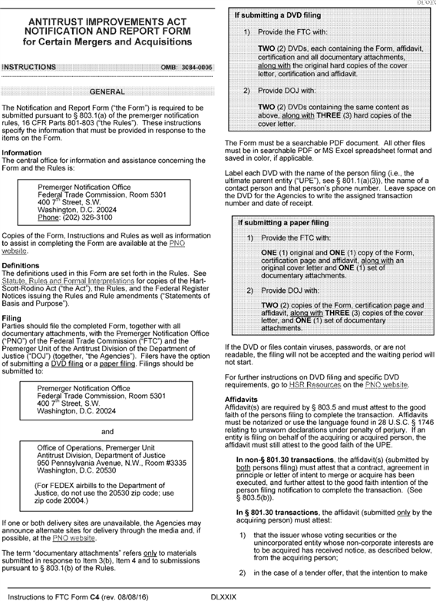

**[*60262]**



**[*60263]**

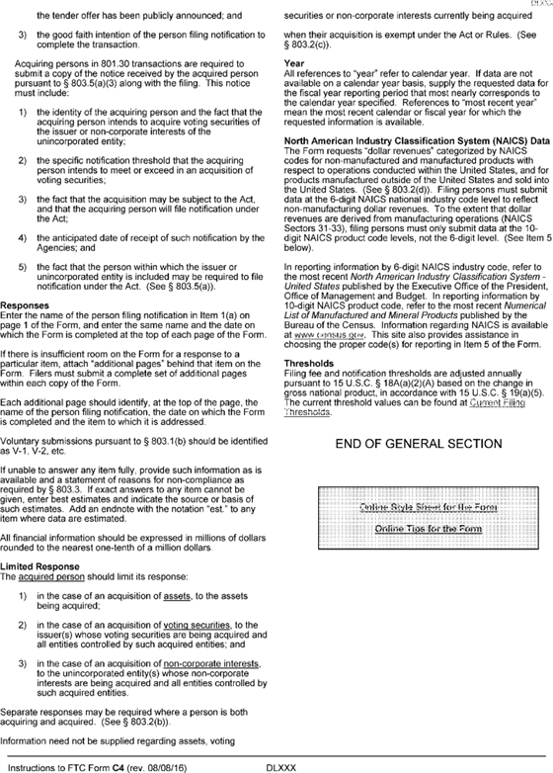

**[*60263]**



**[*60264]**

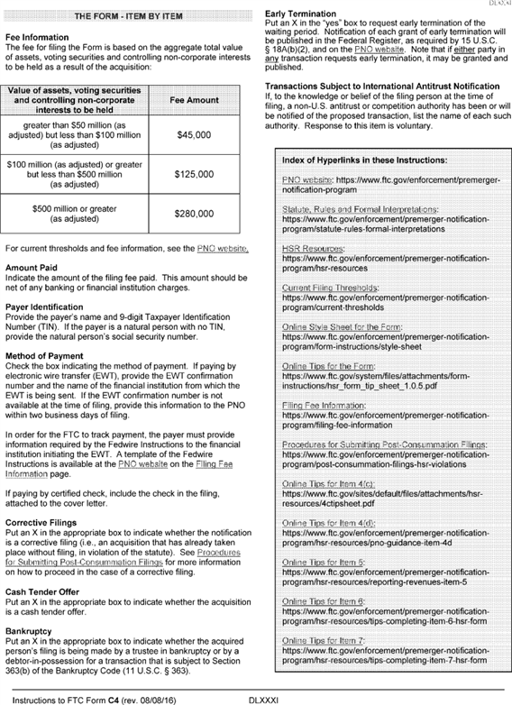

**[*60264]**



**[*60265]**

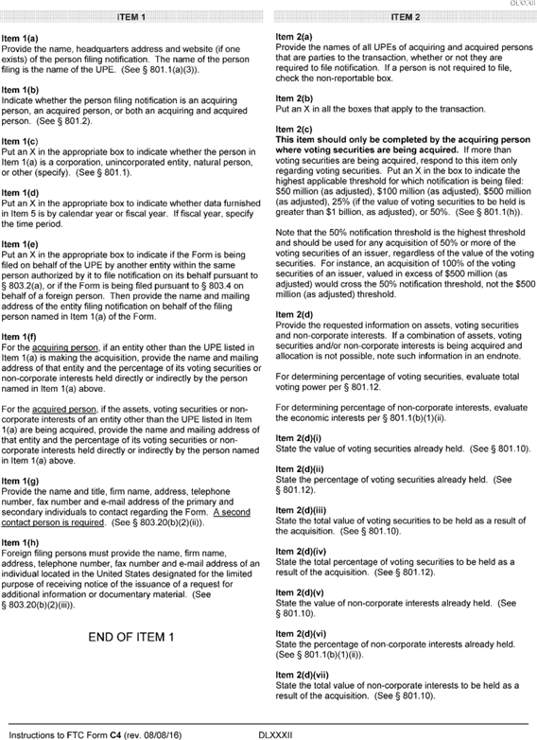

**[*60265]**



**[*60266]**

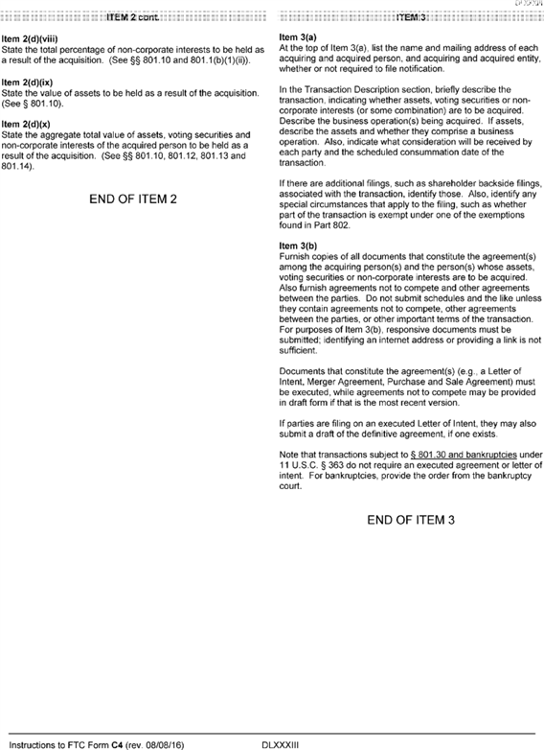

**[*60266]**



**[*60267]**

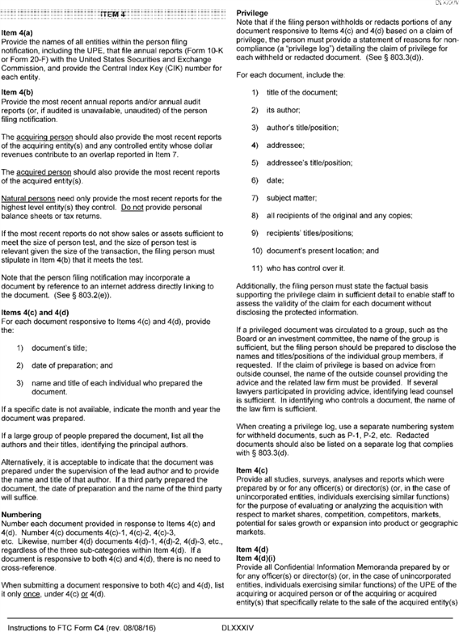

**[*60267]**



**[*60268]**

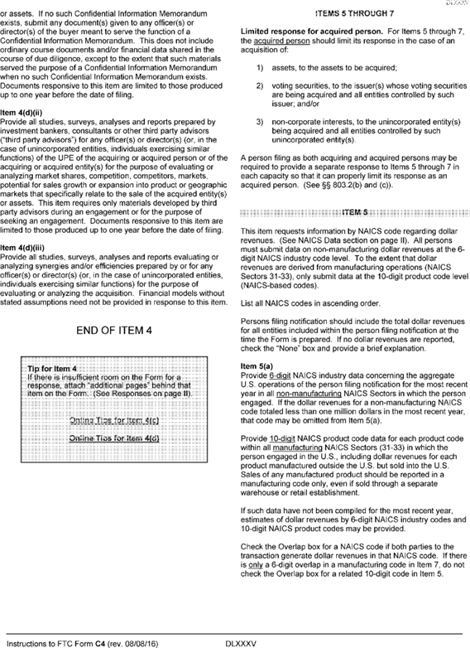

**[*60268]**



**[*60269]**

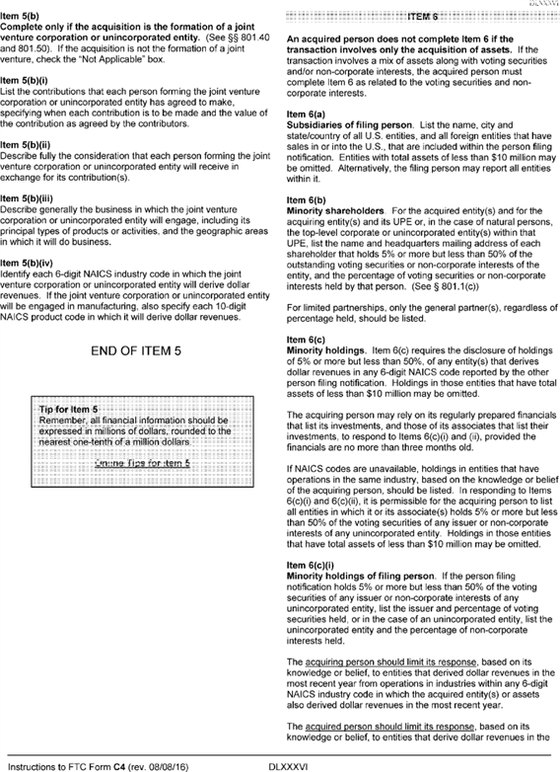

**[*60269]**



**[*60270]**

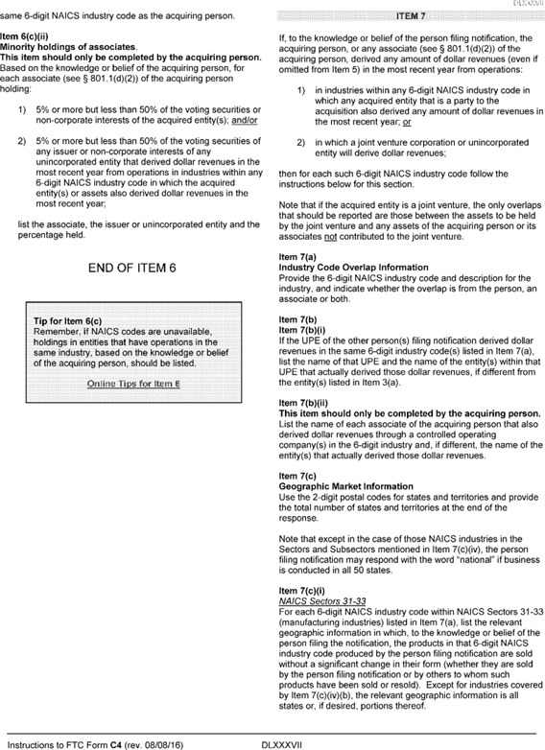

**[*60270]**



**[*60271]**

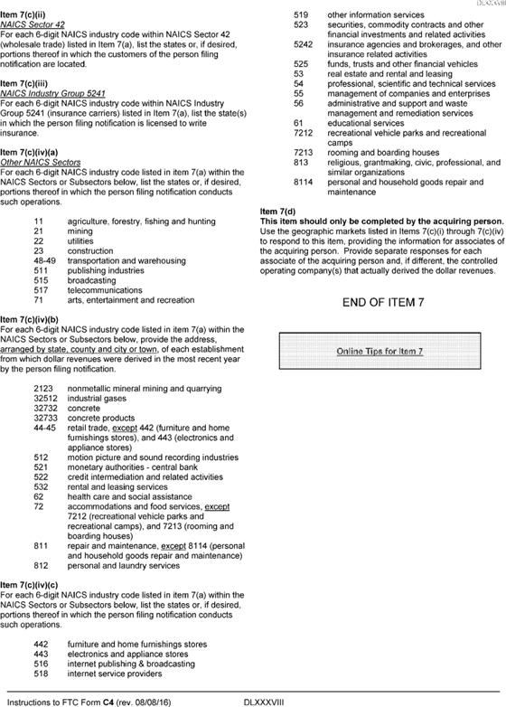

**[*60271]**



**[*60272]**

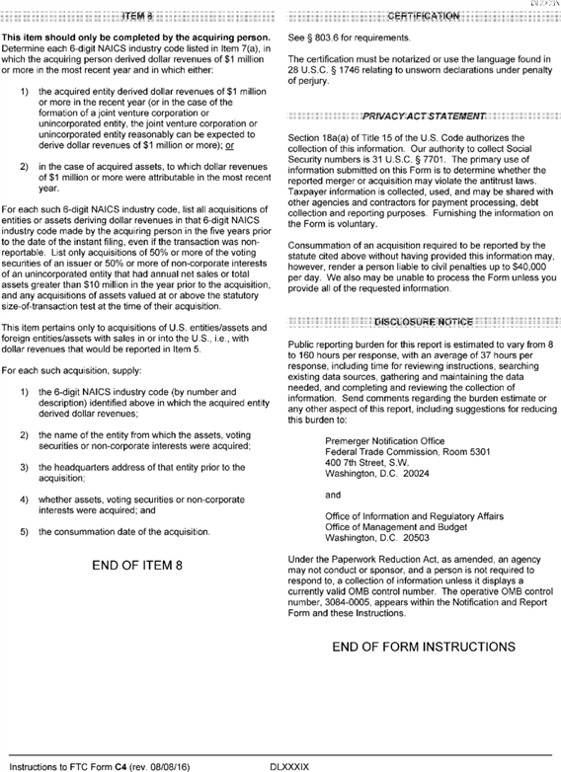

**[*60272]**



**Donald S. Clark,**

*Secretary.*

[FR Doc. 2016-20950 Filed 8-31-16; 8:45 am]

BILLING CODE 6750-01-C

**Dates**

**EFFECTIVE DATE:** Effective September 1, 2016.

**Contacts**

**FOR FURTHER INFORMATION CONTACT:** Robert L. Jones, Assistant Director, Premerger Notification Office, Bureau of ***Competition***, Room 5301, Federal Trade Commission, 400 7th Street SW., Washington, DC 20024. Telephone: (202) 326-3100, Email: [*rjones@ftc.gov*](mailto:rjones@ftc.gov)*.*

FEDERAL REGISTER

**End of Document**